MODEL UNITED NATIONS CLUB
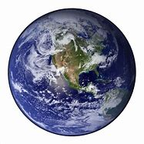
JOIN Dr. Dimitriou fROM Peninsula High for the MUN club. This club exercises public speaking skills as well as policy making. MUN IS VERY UP TO DATE WITH CURRENT EVENTS AND STUDENTS ARE VERY CHALLENGED TO USE A POLICY OF A GIVEN COUNTRY TO SOLVE AN ISSUE.
WHEN: WEDNESDAYS 3:15-4:15
BEGINNING NOVEMBER 30TH – MARCH 2ND
WHERE: ROOM 506
COST: BOOSTER CLUB MEMBERS $80
PLEASE PAY WITH THE “MEMBER PLANET” LINK HERE:
https://mp.gg/4buxy

